Data Science Lab Programs:

Name: Talari Bhavani
Roll Number: 160734754084
Class: CSE-AI(B)

Create an account in github and link the repository with the google colab

PART 1: Create a GitHub Account
1. Go to 👉 https://github.com 2. Click Sign up
3. Enter:

○ Email address ○ bhavanitalari3030@gmail.com
4. Verify your email 5. Choose the free plan 6. Complete the setup

PART 2: Create a New Repository on GitHub
- Log in to your GitHub account

- Click the "+" icon (top right corner)

3. Select New repository

- Enter:

○ Repository name (Bavvi30/2025-26-4084-T.Bhavani-AI-B-DS
○ )

○ Add description (optional)

- Choose:

○ ✅ Public (recommended for learning)

6. Click Create repository

PART 3: Link GitHub Repository with Google Colab

🔹 Method 2: Save Colab Notebook Directly to GitHub
Open Google Colab

Create a new notebook

Click File → Save a copy in GitHub
Authorize GitHub access
Choose:

○ Your repository

○ Branch (usually main)

○ Add commit message

6.Click OK

Date:03/02/2026
Week-1
#Download and save the dataset in the local drive import pandas as pd
#url of dataset(sample csv dataset)
url="https://raw.githubusercontent.com/mwaskom/seaborn-data/refs/heads/maste r/iris.csv"
#read dataset from url df=pd.read_csv(url) #display first few rows print(df.head())
#save dataset to local drive df.to_csv("iris.csv",index=False) print("dataset saved successfully")
sepal_length sepal_width petal_length petal_width species 0 5.1 3.5 1.4 0.2 setosa
- 4.9 3.0 1.4 0.2 setosa
- 4.7 3.2 1.3 0.2 setosa
- 4.6 3.1 1.5 0.2 setosa 4 5.0 3.6 1.4 0.2 setosa dataset saved successfully

#List superstore=["metro",'tesco','walmart','kmart','carrefour']

print(superstore) number_list=[4,4,6,7,2,9,10,15] mixed_list=['cat',87.23,65,[9,7,3,3]] print(type(mixed_list)) #list operations list1=[3,5,7,1] list2=[2,4,6,8] print(list1+list2) #list concartination print(list1*3) print(list1==list2) #string to list quote='Hello World' string_to_list=list(quote) print(string_to_list) # list indexing, slicing print(list1[:2]) print(list1[-2:]) print(5 in list1) print(11 in list1) #list built-in functions cars=['BMW','Audi','Mercedes','Toyota'] print(len(cars)) print(max(number_list)) print(min(number_list)) print(sum(number_list)) print(sorted(list1)) print(sorted(list1,reverse=True))

#list methods cars.append('Tesla') print(cars) cars.insert(2,'Ford') print(cars) cars.remove('Tesla') print(cars) cars.pop() print(cars) #Nested list nested_list=[[1,2,3],[4,5,6],[7,8,9]] print(nested_list) print(nested_list[1]) print(nested_list[1][2])

['metro', 'tesco', 'walmart', 'kmart', 'carrefour']
<class 'list'>
[3, 5, 7, 1, 2, 4, 6, 8]
[3, 5, 7, 1, 3, 5, 7, 1, 3, 5, 7, 1]
False
['H', 'e', 'l', 'l', 'o', ' ', 'W', 'o', 'r', 'l', 'd']
[3, 5]
[7, 1]
True
False
4
15

2
57
[1, 3, 5, 7]
[7, 5, 3, 1]
['BMW', 'Audi', 'Mercedes', 'Toyota', 'Tesla']
['BMW', 'Audi', 'Ford', 'Mercedes', 'Toyota', 'Tesla'] ['BMW', 'Audi', 'Ford', 'Mercedes', 'Toyota']
['BMW', 'Audi', 'Ford', 'Mercedes'] [[1, 2, 3], [4, 5, 6], [7, 8, 9]]
[4, 5, 6]
6

#Tuples a=(1,2,3,4,5) b=(6,7,8,9,10) print(a+b) print(a*3) print(1 in a) print(11 in a) print(a[1:4]) print(len(a))
print(max(a)) print(min(a)) print(sum(a)) print(sorted(a))

print(sorted(a,reverse=True))

(1, 2, 3, 4, 5, 6, 7, 8, 9, 10)
(1, 2, 3, 4, 5, 1, 2, 3, 4, 5, 1, 2, 3, 4, 5)
True
False
(2, 3, 4)
5
5
1
15
[1, 2, 3, 4, 5] [5, 4, 3, 2, 1]

# SET OPERATIONS s1 = {10, 20, 30, 40} s2 = {30, 40, 50, 60} print("Union using method:", s1.union(s2)) print("Intersection using method:", s1.intersection(s2)) print("Difference using method:", s1.difference(s2)) print("Symmetric difference using method:", s1.symmetric_difference(s2))

Union using method: {40, 10, 50, 20, 60, 30}
Intersection using method: {40, 30}
Difference using method: {10, 20}
Symmetric difference using method: {10, 50, 20, 60}

Date:10/02/2026 Week-2
#selecting data:
import pandas as pd
data = { "ID" : [101,102,103,104,105],
"Name": ["Alice", "bob","Charlie","david", "Eva"],
"Age" : [22,25,23,24,26],
"Marks" : [85,78,92,88,90]
}
df = pd.DataFrame (data)
print(df) print(df["Name"])
print("Location 0", df.iloc[0])
print("Location 1 to 4", df.iloc[1:4])
print("Location 1 to 3", df.iloc[1:3])
Output-
ID Name Age Marks
0 101 Alice 22 85
1 102 bob 25 78
2 103 Charlie 23 92
3 104 david 24 88
4 105 Eva 26 90
0 Alice
- bob
- Charlie
3 david
4 Eva
Name: Name, dtype: object
Location 0 ID 101

Name Alice
Age 22
Marks 85
Name: 0, dtype: object
Location 1 to 4 ID Name Age Marks
1 102 bob 25 78
2 103 Charlie 23 92
3 104 david 24 88
Location 1 to 3 ID Name Age Marks
1 102 bob 25 78
2 103 Charlie 23 92

#Data filtering
import pandas as pd
data = {
"ID" : [101,102,103,104,105],
"Name": ["Alice", "bob","Charlie","david", "Eva"],
"Age" : [22,25,23,24,26],
"Marks" : [85,78,92,88,90]
}
df = pd.DataFrame (data)
print(df)
print(df[(df["Name"]=="Alice")|(df["Name"]=="Charlie")]) print(df[df["Marks"]>85])
print(df[df["Age"]<25])
Output-
ID Name Age Marks
0 101 Alice 22 85
- 102 bob 25 78
- 103 Charlie 23 92
3 104 david 24 88
4 105 Eva 26 90
ID Name Age Marks
0 101 Alice 22 85

2 103 Charlie 23 92
ID Name Age Marks
2 103 Charlie 23 92
- 104 david 24 88
- 105 Eva 26 90
ID Name Age Marks
0 101 Alice 22 85
2 103 Charlie 23 92
3 104 david 24 88

#data manupulation import pandas as pd
data = {"Name":["A","B","C"],
"Age":[20,21,22],
"Marks": [70,80,90]}
df=pd.DataFrame(data)
print("Original data:")
print(df)
print("Adding a new column bonus:")
df["Bonus"] = 5
print(df)
print("\nModifiying a column marks:")
df["Marks"] = df["Marks"] + 2
print(df)
print("\nCreating a new column based on other columns:") df["Total"] = df["Marks"] + df["Bonus"]
print(df)
print("\nRenaming a column:")
df.rename(columns={"Total":"Final"},inplace = True )
print(df)
print("\nDroping a column:")
df.drop("Bonus",axis=1,inplace=True) print(df)
print("\nDroping a row:")
df.drop(1,axis=0,inplace=True)
print(df)
print("\nChanging a particular value:")
df.loc[0,"Age"]=21

print(df)
Output-
Original data:
Name Age Marks
0 A 20 70
1 B 21 80
2 C 22 90
Adding a new column bonus:
Name Age Marks Bonus
- A 20 70 5
- B 21 80 5
2 C 22 90 5
Modifiying a column marks:
Name Age Marks Bonus
0 A 20 72 5
- B 21 82 5
- C 22 92 5
Creating a new column based on other columns:
Name Age Marks Bonus Total
0 A 20 72 5 77
1 B 21 82 5 87
2 C 22 92 5 97

Renaming a column:
Name Age Marks Bonus Final
0 A 20 72 5 77
1 B 21 82 5 87
2 C 22 92 5 97
Droping a column:
Name Age Marks Final
0 A 20 72 77
1 B 21 82 87
2 C 22 92 97
Droping a row:

Name Age Marks Final
0 A 20 72 77
2 C 22 92 97
Changing a particular value:
Name Age Marks Final
0 A 21 72 77
2 C 22 92 97

#Selection sort
n=int(input("Enter number of elements:")) arr=[]
for i in range(n):
arr.append(int(input(f"Enter element{i+1}:")))
print("\n Original array:",arr)
for i in range(n-1):
min_index=i
for j in range(i+1,n):
if arr[j]<arr[min_index]:
min_index=j
arr[i],arr[min_index]=arr[min_index],arr[i]
print("sorted array:",arr)
Output-
Enter number of elements:3
Enter element1:12
Enter element2:13
Enter element3:12
Original array: [12, 13, 12]
sorted array: [12, 12, 13]

# Bubble Sort
def bubble_sort(arr):
n = len(arr)
for i in range(n - 1):

# Last i elements are already in place
for j in range(0, n - i - 1):
# Traverse the array from 0 to n-i-1
# Swap if the element found is greater than the next element if arr[j] > arr[j + 1]:
arr[j], arr[j + 1] = arr[j + 1], arr[j]
return arr
# Example usage:
my_list = [64, 34, 25, 12, 22, 11, 90]
print("Original array:", my_list) sorted_list = bubble_sort(my_list)
print("Sorted array:", sorted_list)
Output-
Original array: [64, 34, 25, 12, 22, 11, 90]
Sorted array: [11, 12, 22, 25, 34, 64, 90]

#linear search
n=int(input("Enter number of elements:"))
arr=[]
for i in range(n):
arr.append(int(input(f"Enter element{i+1}:")))
key= int(input("Enter the element to be searched:"))
found=False for i in range(n):
if arr[i]==key:
print(f"Element found at position{i+1}")
found = True
if found == False:
print("Elementnot found")
Output-
Enter number of elements:5
Enter element1:2
Enter element2:3
Enter element3:5
Enter element4:6

Enter element5:5
Enter the element to be searched:2
Element found at position1

#binary search
n=int(input("Enter number of elements:"))
arr=[]
for i in range(n):
arr.append(int(input(f"Enter element{i+1}:")))
arr.sort()
print("\nSorted list:", arr)
key= int(input("Enter the element to be searched:"))
low = 0
high = n - 1
found = False
while low <= high:
mid = (low + high) // 2
if arr[mid] == key:
print(f"Element found at position {mid + 1}")
found = True
break
elif arr[mid] < key:
high = mid + 1
else:
high = mid - 1 if not found:
print("Element not found")
Output-
Enter number of elements:3
Enter element1:1
Enter element2:2
Enter element3:3
Sorted list: [1, 2, 3]
Enter the element to be searched:2
Element found at position 2

#grouping data
import pandas as pd
data={
"Department":["CSE","CSM","AI","CSE" , "CSM"],
"Name":["Alice", "Bob", "Charilie", "David" , "Eva"],
"Marks":[22,25,23,24,26],
}
df=pd.DataFrame(data)
print("Original data:")
print(df)
print("\nAvarege marks by department:") print(df.groupby("Department")["Marks"].mean())
print("\nTotal marks by department:")
print(df.groupby("Department")["Marks"].sum())
print("student count by department:")
print(df.groupby("Department")["Marks"].count())
Output- Original data:
Department Name Marks
0 CSE Alice 22
1 CSM Bob 25
2 AI Charilie 23
3 CSE David 24
4 CSM Eva 26

Avarege marks by department:
Department
AI 23.0
CSE 23.0
CSM 25.5
Name: Marks, dtype: float64

Total marks by department:
Department
AI 23
CSE 46
CSM 51
Name: Marks, dtype: int64

student count by department:
Department
AI 1
CSE 2
CSM 2
Name: Marks, dtype: int64

#rearranging the data
import pandas as pd
data={
"Name":["Alice", "Bob", "Charilie", "David" , "Eva"],
"Marks":[22,25,23,24,26],
"Age":[20,21,22,23,24]
}
df=pd.DataFrame(data)
print(df)
df_sorted=df.sort_values(by="Marks",ascending=False)
print("\nSorted data:") print(df_sorted)
print("\nSorted in descending order")
df_rearranged_cols=df[["Marks", "Name" , "Age"]]
print(df_rearranged_cols)
Output-
Name Marks Age
0 Alice 22 20
1 Bob 25 21
2 Charilie 23 22
3 David 24 23
4 Eva 26 24
Sorted data:
Name Marks Age
4 Eva 26 24
1 Bob 25 21
3 David 24 23
2 Charilie 23 22
0 Alice 22 20

Sorted in descending order
Marks Name Age
- 22 Alice 20
- 25 Bob 21
2 23 Charilie 22
3 24 David 23
4 26 Eva 24

#ranking
import pandas as pd data={
"Name":["A", "B", "C", "D" , "E"],
"Marks":[80,45,90,33,70]
}
df=pd.DataFrame(data)
print(df)
df["rank"]=df["Marks"].rank(ascending=False) print("\nAfter Ranking:")
print(df)
Output-
Name Marks
0 A 80
- B 45
- C 90
3 D 33
4 E 70
After Ranking:
Name Marks rank
- A 80 2.0
- B 45 4.0
2 C 90 1.0
3 D 33 5.0
4 E 70 3.0

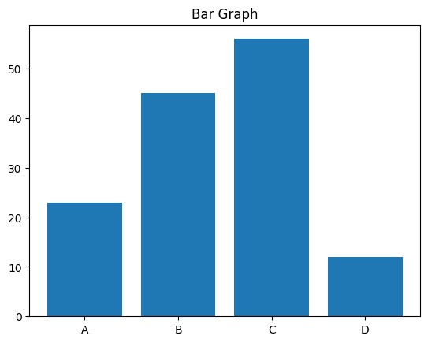
plotting

import

matplotlib.pyplot

as

plt

categories

=

[
'A'
,

'B'
,

'C'
,

'D'
]

values

=

[
23
,

45
,

56
,

12
]

plt.bar
(
categories
,

values
)

plt.title
(
'Bar

Graph'
)

plt.show
()

output-

# scatter plot
import matplotlib.pyplot as plt

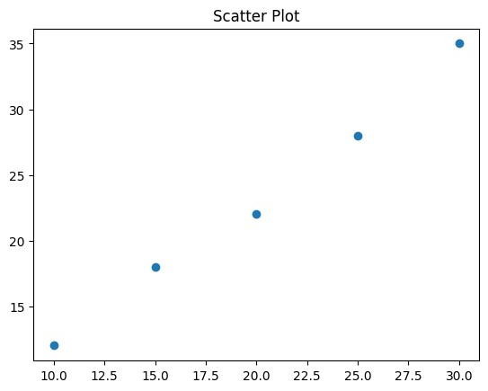

x

=

[
10
,

15
,

20
,

25
,

30
]

y

=

[
12
,

18
,

22
,

28
,

35
]

plt.scatter
(
x
,

y
)

plt.title
(
'Scatter

Plot'
)

plt.show
()

output-

# pie chart
import matplotlib.pyplot as plt
labels = ['Apples', 'Bananas', 'Cherries']
quantities = [30, 25, 15]

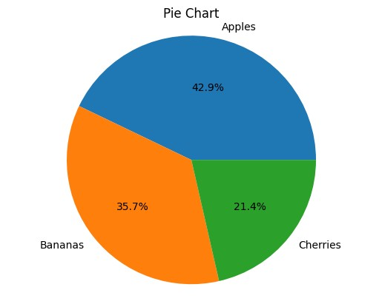
plt.pie
(
quantities
,

labels=labels
,

autopct=
'%1.1f%%'
)

plt.title
(
'Pie

Chart'
)

plt.axis
(
'equal'
)

plt.show
()

Output-

# histogram
import matplotlib.pyplot as plt
import numpy as np
data_hist = np.random.normal(0, 1, 100)
plt.hist(data_hist)
plt.title('Histogram') plt.show()
Output-

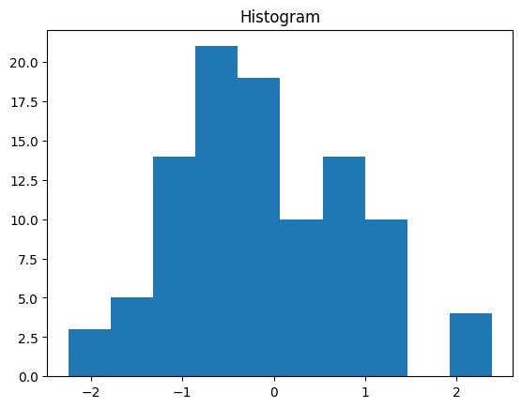

# box plot
import matplotlib.pyplot as plt
import numpy as np
data_box = [np.random.normal(0, 1, 10), np.random.normal(1, 1.5, 10)]
plt.boxplot(data_box) plt.title('Box Plot')
plt.show()
Output-

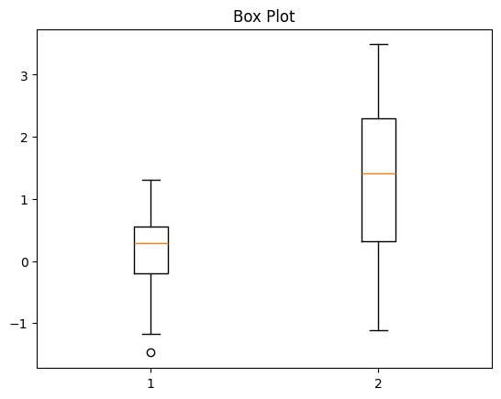

Date:17/02/2025

Week-3
#Performing data manipulations, data operations, ranking on a dataset
import pandas as pd
url="https://raw.githubusercontent.com/mwaskom/seaborn-data/master/tips.
csv"
df=pd.read_csv(url)
print("Original Dataset:")
print(df.head())
print("\nRecords where Total_Bill>20 and Tips>3")
filtered_and=df[(df['total_bill']>20)&(df['tip']>3)]
print(filtered_and)
print("\nRecords where Day is Saturday or Sunday") filtered_or=df[(df['day']=='Sat')|(df['day']=='Sun')]
print(filtered_or)

print("\nRecords where Smoker is NOR Yes")
filtered_not=df[~(df['smoker']=='Yes')]
print(filtered_not)
print("\nFemale and Non-Smoker and Total_Bill>15")
combined_filter=df[(df['sex']=='Female')&(df['smoker']=='No')&(df['total
_bill']>15)]
print(combined_filter)
print("\nNumber of records satisfying combined
condition:",len(combined_filter))
print("\nSorted by Total_Bill in ascending order:")
sorted_asc=df.sort_values(by='total_bill') print(sorted_asc.head())
print("\nSorted by Tip in descending order:")
sorted_desc=df.sort_values(by='tip',ascending=False)
print(sorted_desc.head())
print("\nSorted by Day and Total_Bill")
sorted_multi=df.sort_values(by=['day','total_bill'])
print(sorted_multi.head()) print("\nAverage Total Bill by Day")
group_day=df.groupby('day')['total_bill'].mean()
print(group_day)
print("\nAverage Tip by Sex and Smoker")
group_multi=df.groupby(['sex','smoker'])['tip'].mean()
print(group_multi)
print("\nCount of Records by Day") group_count=df.groupby('day').size()
print(group_count)
Output-
Original Dataset:
total_bill tip sex smoker day time size
- 16.99 1.01 Female No Sun Dinner 2
- 10.34 1.66 Male No Sun Dinner 3
2 21.01 3.50 Male No Sun Dinner 3
3 23.68 3.31 Male No Sun Dinner 2
4 24.59 3.61 Female No Sun Dinner 4
Records where Total_Bill>20 and Tips>3
total_bill tip sex smoker day time size

2 21.01 3.50 Male No Sun Dinner 3
3 23.68 3.31 Male No Sun Dinner 2
4 24.59 3.61 Female No Sun Dinner 4
5 25.29 4.71 Male No Sun Dinner 4
7 26.88 3.12 Male No Sun Dinner 4
.. ... ... ... ... ... ... ...
212 48.33 9.00 Male No Sat Dinner 4
214 28.17 6.50 Female Yes Sat Dinner 3
219 30.14 3.09 Female Yes Sat Dinner 4
238 35.83 4.67 Female No Sat Dinner 3
239 29.03 5.92 Male No Sat Dinner 3

[67 rows x 7 columns]
Records where Day is Saturday or Sunday
total_bill tip sex smoker day time size
0 16.99 1.01 Female No Sun Dinner 2
- 10.34 1.66 Male No Sun Dinner 3
- 21.01 3.50 Male No Sun Dinner 3
3 23.68 3.31 Male No Sun Dinner 2
4 24.59 3.61 Female No Sun Dinner 4
.. ... ... ... ... ... ... ...
238 35.83 4.67 Female No Sat Dinner 3
239 29.03 5.92 Male No Sat Dinner 3
- 27.18 2.00 Female Yes Sat Dinner 2
- 22.67 2.00 Male Yes Sat Dinner 2
242 17.82 1.75 Male No Sat Dinner 2
[163 rows x 7 columns]
Records where Smoker is NOR Yes
total_bill tip sex smoker day time size 0 16.99 1.01 Female No Sun Dinner 2
1 10.34 1.66 Male No Sun Dinner 3
2 21.01 3.50 Male No Sun Dinner 3
3 23.68 3.31 Male No Sun Dinner 2
4 24.59 3.61 Female No Sun Dinner 4
.. ... ... ... ... ... ... ...
235 10.07 1.25 Male No Sat Dinner 2

238 35.83 4.67 Female No Sat Dinner 3
239 29.03 5.92 Male No Sat Dinner 3
242 17.82 1.75 Male No Sat Dinner 2
243 18.78 3.00 Female No Thur Dinner 2

[151 rows x 7 columns]
Female and Non-Smoker and Total_Bill>15
total_bill tip sex smoker day time size
0 16.99 1.01 Female No Sun Dinner 2
4 24.59 3.61 Female No Sun Dinner 4
11 35.26 5.00 Female No Sun Dinner 4
18 16.97 3.50 Female No Sun Dinner 3
21 20.29 2.75 Female No Sat Dinner 2
22 15.77 2.23 Female No Sat Dinner 2
29 19.65 3.00 Female No Sat Dinner 2
32 15.06 3.00 Female No Sat Dinner 2
33 20.69 2.45 Female No Sat Dinner 4
37 16.93 3.07 Female No Sat Dinner 3
52 34.81 5.20 Female No Sun Dinner 4
57 26.41 1.50 Female No Sat Dinner 2
66 16.45 2.47 Female No Sat Dinner 2
71 17.07 3.00 Female No Sat Dinner 3
85 34.83 5.17 Female No Thur Lunch 4
94 22.75 3.25 Female No Fri Dinner 2
104 20.92 4.08 Female No Sat Dinner 2
114 25.71 4.00 Female No Sun Dinner 3
115 17.31 3.50 Female No Sun Dinner 2
119 24.08 2.92 Female No Thur Lunch 4
125 29.80 4.20 Female No Thur Lunch 6
131 20.27 2.83 Female No Thur Lunch 2
134 18.26 3.25 Female No Thur Lunch 2
140 17.47 3.50 Female No Thur Lunch 2
143 27.05 5.00 Female No Thur Lunch 6
144 16.43 2.30 Female No Thur Lunch 2
146 18.64 1.36 Female No Thur Lunch 3
155 29.85 5.14 Female No Sun Dinner 5
157 25.00 3.75 Female No Sun Dinner 4
162 16.21 2.00 Female No Sun Dinner 3

223 15.98 3.00 Female No Fri Lunch 3
238 35.83 4.67 Female No Sat Dinner 3
243 18.78 3.00 Female No Thur Dinner 2
Number of records satisfying combined condition: 33
Sorted by Total_Bill in ascending order:
total_bill tip sex smoker day time size
67 3.07 1.00 Female Yes Sat Dinner 1
92 5.75 1.00 Female Yes Fri Dinner 2
111 7.25 1.00 Female No Sat Dinner 1
172 7.25 5.15 Male Yes Sun Dinner 2
149 7.51 2.00 Male No Thur Lunch 2
Sorted by Tip in descending order:
total_bill tip sex smoker day time size
170 50.81 10.00 Male Yes Sat Dinner 3
212 48.33 9.00 Male No Sat Dinner 4
23 39.42 7.58 Male No Sat Dinner 4
59 48.27 6.73 Male No Sat Dinner 4
141 34.30 6.70 Male No Thur Lunch 6
Sorted by Day and Total_Bill
total_bill tip sex smoker day time size
92 5.75 1.00 Female Yes Fri Dinner 2
222 8.58 1.92 Male Yes Fri Lunch 1
226 10.09 2.00 Female Yes Fri Lunch 2
100 11.35 2.50 Female Yes Fri Dinner 2
97 12.03 1.50 Male Yes Fri Dinner 2
Average Total Bill by Day
day Fri 17.151579
Sat 20.441379
Sun 21.410000
Thur 17.682742
Name: total_bill, dtype: float64
Average Tip by Sex and Smoker

sex smoker
Female No 2.773519
Yes 2.931515
Male No 3.113402
Yes 3.051167
Name: tip, dtype: float64
Count of Records by Day
day
Fri 19
Sat 87
Sun 76
Thur 62
dtype: int64

# Performing data manipulations + visualization
import pandas as pd
import matplotlib.pyplot as plt
import seaborn as sns
# Load dataset
url =
"https://raw.githubusercontent.com/mwaskom/seaborn-data/master/tips.csv"
df = pd.read_csv(url)
print("Original Dataset:")
print(df.head())
filtered_and = df[(df['total_bill'] > 20) & (df['tip'] > 3)]
filtered_or = df[(df['day'] == 'Sat') | (df['day'] == 'Sun')]
filtered_not = df[~(df['smoker'] == 'Yes')] combined_filter = df[(df['sex'] == 'Female') &
(df['smoker'] == 'No') &
(df['total_bill'] > 15)]
sorted_asc = df.sort_values(by='total_bill')
sorted_desc = df.sort_values(by='tip', ascending=False)

sorted_multi = df.sort_values(by=['day', 'total_bill'])
group_day = df.groupby('day')['total_bill'].mean()
group_multi = df.groupby(['sex', 'smoker'])['tip'].mean() group_count = df.groupby('day').size()
sns.set(style="whitegrid")
# Scatter Plot: Total Bill vs Tip
plt.figure(figsize=(8,5))
sns.scatterplot(data=df, x='total_bill', y='tip', hue='sex') plt.title("Total Bill vs Tip")
plt.show()
# Bar Plot: Average Total Bill by Day
plt.figure(figsize=(8,5))
sns.barplot(x=group_day.index, y=group_day.values)
plt.title("Average Total Bill by Day") plt.xlabel("Day")
plt.ylabel("Average Total Bill")
plt.show()
# Bar Plot: Average Tip by Sex and Smoker
plt.figure(figsize=(8,5))
group_multi.unstack().plot(kind='bar') plt.title("Average Tip by Sex and Smoker")
plt.ylabel("Average Tip")
plt.xticks(rotation=0)
plt.show()
# Count Plot: Number of Records by Day
plt.figure(figsize=(8,5)) sns.countplot(data=df, x='day')
plt.title("Count of Records by Day")
plt.show()
# Histogram: Distribution of Total Bill
plt.figure(figsize=(8,5))
sns.histplot(df['total_bill'], bins=20, kde=True)

plt.title("Distribution of Total Bill")
plt.show()
# Boxplot: Total Bill by Day plt.figure(figsize=(8,5))
sns.boxplot(data=df, x='day', y='total_bill')
plt.title("Total Bill Distribution by Day")
plt.show()
# Boxplot: Tips for Filtered Condition
plt.figure(figsize=(8,5))
sns.boxplot(data=combined_filter, x='sex', y='tip')
plt.title("Tips (Female, Non-Smoker, Total Bill > 15)")
plt.show()
Output-
Original Dataset:
total_bill tip sex smoker day time size 0 16.99 1.01 Female No Sun Dinner 2
1 10.34 1.66 Male No Sun Dinner 3
2 21.01 3.50 Male No Sun Dinner 3
3 23.68 3.31 Male No Sun Dinner 2
4 24.59 3.61 Female No Sun Dinner 4

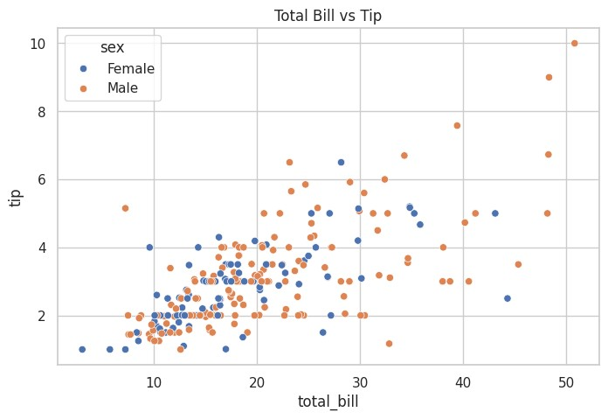

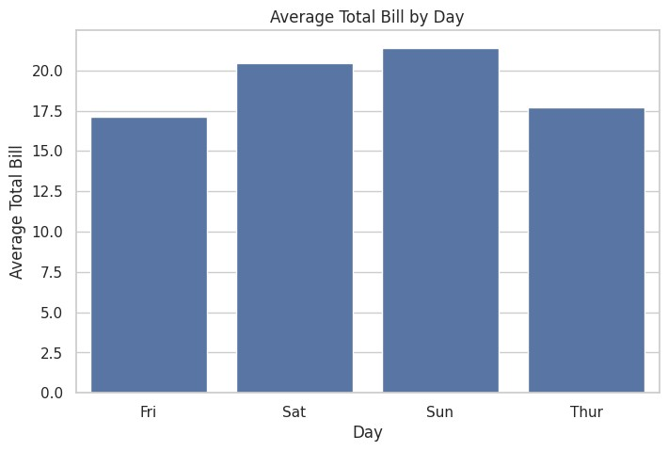

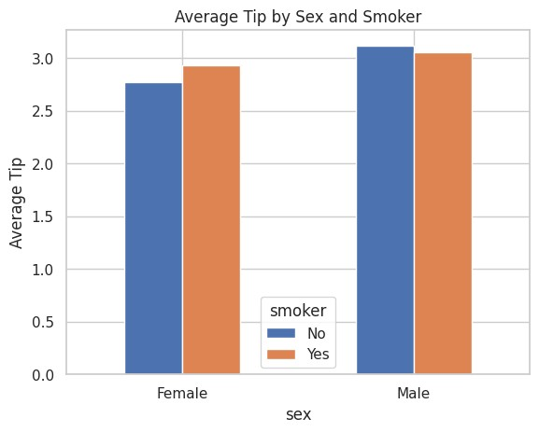

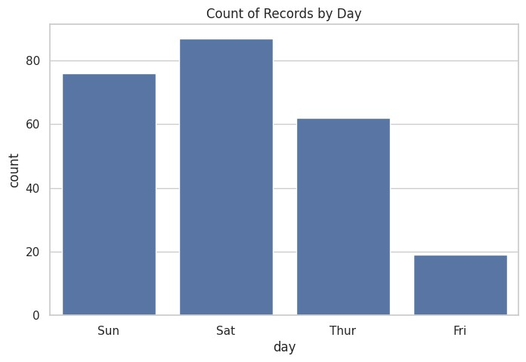
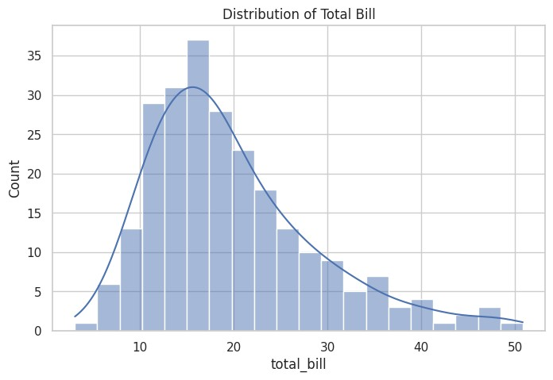
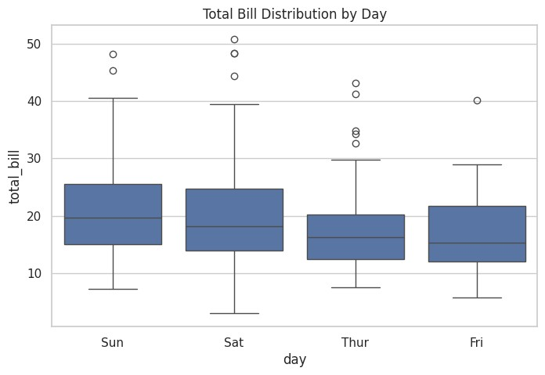

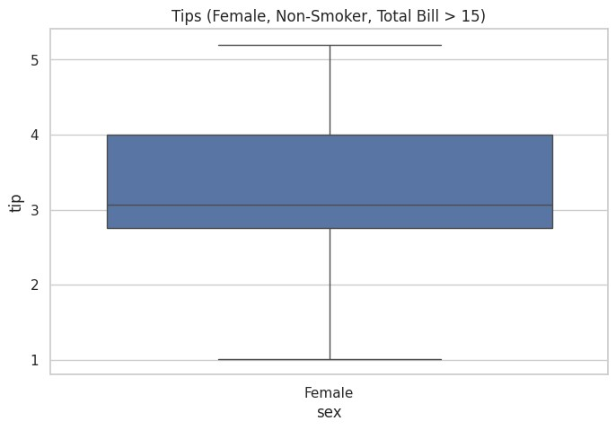

#exploring data analysis(EDA) on simple data
import pandas as pd
import numpy as np
import matplotlib.pyplot as plt
data=[10,20,30,22,34,56,67,34,45,40]
df=pd.DataFrame(data,columns=['Age']) print("Original Dataset:")
print(df)
print("\nSummery statistics:")
print(df.describe())
print("\nVariance:", np.var(data))
print("\nStandard Deviation:", np.std(data))
plt.hist(data)
plt.title("Data Distribution")
plt.ylabel("Frequency")
plt.show()

mean_value=np.mean(data)
median_value=np.median(data)
print("\nMean:", mean_value)
print("\nMedian:", median_value) if mean_value>median_value:
print("\ndata is slightly right-skewed")
elif mean_value<median_value:
print("\ndata is slightly left-skewed")
else:
print("\nData is symmetric")
Output-
Original Dataset:
Age
0 10
1 20
2 30
- 22
- 34
5 56
6 67
7 34
8 45
9 40
Summery statistics:
Age
count 10.000000
mean 35.800000
std 17.093209
min 10.000000
25% 24.000000
50% 34.000000
75% 43.750000
max 67.000000
Variance: 262.9599999999999
Standard Deviation: 16.216041440499588

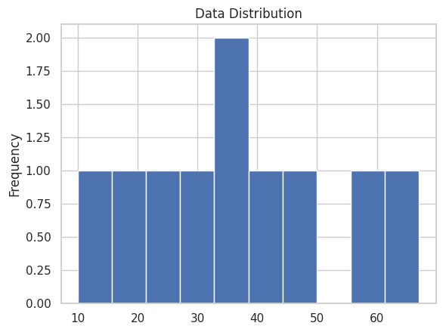

Mean:

35.8

Median:

34.0

data

is

slightly

right-skewed

#EDA on a dataset
import pandas as pd
import numpy as np
import matplotlib.pyplot as plt
url="https://raw.githubusercontent.com/mwaskom/seaborn-data/master/iris.
csv"
df=pd.read_csv(url)
print("Dataset(first 10 rows):")
print(df.head(10))
data=df['sepal_length']
print("\nSummary statistics:")

print(df.describe())
print("\nVariance:", np.var(data))
print("\nStandard Deviation:", np.std(data))
plt.hist(data,bins=10, colour='skyblue',edgecolor='black')
plt.axvline(np.mean(data),color='red',linestyle='dashed',linewidth=2,lab
el=f"Mean:{np.mean(data):.2f}")
plt.axvline(np.mean(data),color='red',linestyle='dashed',linewidth=2,lab
el=f"Median:{np.median(data):.2f}")
plt.ylabel("Frequency")
plt.title("Data Distribution")
plt.legend() plt.show()
mean_value=np.mean(data)
median_value=np.median(data)
print("Inference values:")
print("\nMean:", mean_value)
print("\nMedian:", median_value)
if mean_value>median_value:
print("\ndata is slightly right-skewed")
elif mean_value<median_value:
print("Data is slightly left-skewed")
else:
print("\n Dtsts is symmetric")
Output-
Dataset(first 10 rows):
sepal_length sepal_width petal_length petal_width species
0 5.1 3.5 1.4 0.2 setosa
1 4.9 3.0 1.4 0.2 setosa
2 4.7 3.2 1.3 0.2 setosa
3 4.6 3.1 1.5 0.2 setosa
4 5.0 3.6 1.4 0.2 setosa
5 5.4 3.9 1.7 0.4 setosa
6 4.6 3.4 1.4 0.3 setosa
7 5.0 3.4 1.5 0.2 setosa
8 4.4 2.9 1.4 0.2 setosa
9 4.9 3.1 1.5 0.1 setosa
Summary statistics:
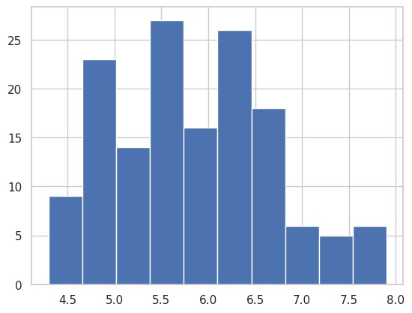

sepal_length

sepal_width

petal_length

petal_width

count

150.000000

150.000000

150.000000

150.000000

mean

5.843333

3.057333

3.758000

1.199333

std

0.828066

0.435866

1.765298

0.762238

min

4.300000

2.000000

1.000000

0.100000

25
%

5.100000

2.800000

1.600000

0.300000

50
%

5.800000

3.000000

4.350000

1.300000

75
%

6.400000

3.300000

5.100000

1.800000

max

7.900000

4.400000

6.900000

2.500000

Variance:

0.6811222222222222

Standard

Deviation:

0.8253012917851409

Date:24/02/2026 Week-4
#Descriptive Statistics import pandas as pd data={
"Ages":[22,25,47,35,46,50,28,33,39,41], "Salaries":[3000,3200,5500,4000,5200,6000,3500,3700,4500,4800]
}
df=pd.DataFrame(data) print("Original DataFrame:") print(df)
print("\nSummary Statistics:\n") print(df.describe()) print("\nMean:\n",df.mean()) print("\nMedian:",df.median()) print("\nMode:\n",df.mode()) print("\nMinimum value:\n",df.min()) print("\nMaximum value:\n",df.max()) print("\nStandard Deviation:\n",df.std()) print("\nVariance:\n",df.var()) print("\nSkewness:\n",df.skew()) print("\nKurtosis:\n",df.kurt())

Original DataFrame:
Ages Salaries
- 22 3000
- 25 3200
- 47 5500
- 35 4000
- 46 5200
- 50 6000
- 28 3500
- 33 3700
- 39 4500
- 41 4800

Summary Statistics:

Ages Salaries count 10.000000 10.000000 mean 36.600000 4340.000000 std 9.651713 1022.198067 min 22.000000 3000.000000 25% 29.250000 3550.000000
50% 37.000000 4250.000000 75% 44.750000 5100.000000 max 50.000000 6000.000000

Mean:
Ages 36.6
Salaries 4340.0

dtype: float64

Median: Ages 37.0
Salaries 4250.0 dtype: float64

Mode:
Ages Salaries
- 22 3000
- 25 3200
- 28 3500
- 33 3700
- 35 4000
- 39 4500
- 41 4800
- 46 5200
- 47 5500
- 50 6000

Minimum value:
Ages 22
Salaries 3000 dtype: int64

Maximum value:
Ages 50
Salaries 6000 dtype: int64

Standard Deviation:
Ages 9.651713
Salaries 1022.198067 dtype: float64

Variance:
Ages 9.315556e+01
Salaries 1.044889e+06 dtype: float64

Skewness:
Ages -0.138915
Salaries 0.271889 dtype: float64

Kurtosis:
Ages -1.287437
Salaries -1.223068 dtype: float64

#Replacing missing values in dataset import pandas as pd
# Creating a sample dataset with missing values data = {
'Name': ['Alice', 'Bob', 'Charlie', 'David', 'Eve'],

'Age': [25, None, 35, 40, 28], # Bob has missing age
'Salary': [50000, 60000, None, 70000, 62000], # Charlie has missing salary
'Allowances': [2000, None, 2000, 2000, 2500] # Bob has missing allowance
}
df = pd.DataFrame(data)
# 1. Checking for missing values in each column print("Missing Values Count:\n", df.isnull().sum())
# 2. Dropping rows with any missing values df_cleaned = df.dropna()
print("\nDataFrame after dropping missing values:\n", df_cleaned) # 3. Filling missing values with specific values df_filled = df.fillna({'Age': df['Age'].mean(), 'Salary':
df['Salary'].mean(), 'Allowances': 2000})
print("\nDataFrame after filling missing values:\n", df_filled)
Missing Values Count:
Name 0
Age 1
Salary 1 Allowances 1 dtype: int64

DataFrame after dropping missing values:
Name Age Salary Allowances
0 Alice 25.0 50000.0 2000.0
- David 40.0 70000.0 2000.0
- Eve 28.0 62000.0 2500.0

DataFrame after filling missing values:
Name Age Salary Allowances
- Alice 25.0 50000.0 2000.0
- Bob 32.0 60000.0 2000.0
- Charlie 35.0 60500.0 2000.0
- David 40.0 70000.0 2000.0
- Eve 28.0 62000.0 2500.0

#Interquantile Range(IQR) import pandas as pd data={
'Name':['A','B','C','D','E','F'], 'Age':[13,24,25,29,120,23]
}
df=pd.DataFrame(data) print("Original DataFrame:") print(df)
Q1=df['Age'].quantile(0.25)
Q3=df['Age'].quantile(0.75) IQR=Q3-Q1
print("\nInterquantile Range(IQR):",IQR) lower_bound=Q1-1.5*IQR upper_bound=Q3+1.5*IQR
print("\nLower Bound:",lower_bound)

print("\nUpper Bound:",upper_bound) outliers=df[(df['Age']upper_bound)] print("\nOutliers using IQR method:") print(outliers)

Original DataFrame:
Name Age
- A 13
- B 24
- C 25
- D 29
- E 120
- F 23

Interquantile Range(IQR): 4.75

Lower Bound: 16.125
Upper Bound: 35.125

Outliers using IQR method:
Name Age
0 A 13
4 E 120

#Data Distribution import numpy as np import pandas as pd
import matplotlib.pyplot as plt
normal_data=np.random.normal(loc=70,scale=5,size=1000) right_skewed=np.random.exponential(scale=2,size=1000) left_skewed=np.random.exponential(scale=2,size=1000) plt.hist(normal_data,bins=30) plt.title("Normal Distribution") plt.show()
plt.hist(right_skewed,bins=30) plt.title("Right Skewed Distribution") plt.show()
plt.hist(left_skewed,bins=30) plt.title("Left Skewed Distribution") plt.show()
print("Normal Data Mean:",np.mean(normal_data)) print("Normal Data Median:",np.median(normal_data)) print("Right Skewed Mean:",np.mean(right_skewed)) print("Right Skewed Median:",np.median(right_skewed)) print("Left Skewed Mean:",np.mean(left_skewed)) print("Left Skewed Median:",np.median(left_skewed))

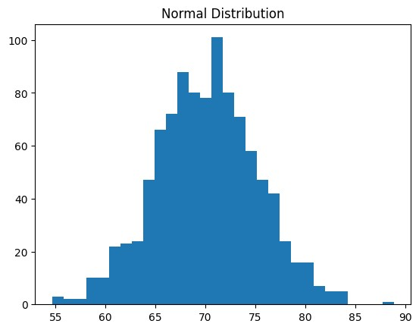

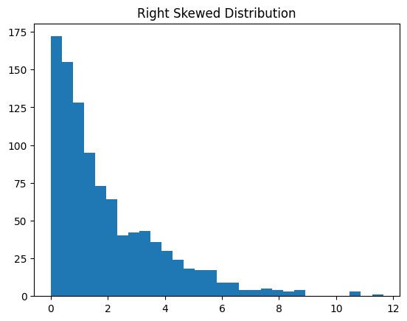

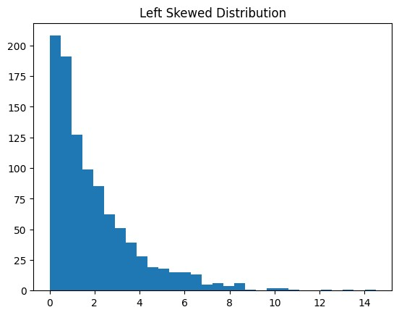

Normal

Data

Mean:

70.18352247456075

Normal

Data

Median:

70.25535929978902

Right

Skewed

Mean:

1.9772751069397216

Right

Skewed

Median:

1.3718002756956356

Left

Skewed

Mean:

1.9710714063382366

Left

Skewed

Median:

1.3370186167188536

#Class

Activity

import

pandas

as

pd

import

matplotlib.pyplot

as

plt

import

numpy

as

np

data={

'BMI'
:[
18
,
19
,
20
,
21
,
22
,
23
,
24
,
25
,
26
,
27
,
28
,
29
,
30
,
31
,
32
,
35
,
38
,
42
,
45
,
50
]

}

df=pd.DataFrame(data)

plt.hist(df[
'BMI'
]
,bins
=
6
)

plt.title(
"BMI

Distribution"
)

plt.show()

print
(
"\nMean:"
,df[
'BMI'
]
.mean
())

print
(
"\nMedian:"
,df[
'BMI'
]
.median
())

print
(
"\nSkewness:"
,df[
'BMI'
]
.skew
())

print
(
"\nKurtosis:"
,df[
'BMI'
]
.kurt
())

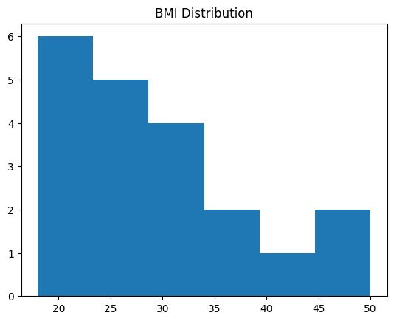

Mean:

29.25

Median:

27.5

Skewness:

0.9198000777230567

Kurtosis:

0.2176389101466749

WEEK: 5
#z-score,statistical inference,random variable model,central limit theorem,standardizations
import numpy as np
import math
population=np.array([10,20,30,40,50,60,70])
N=len(population)
print("\nPopulation Size(N):",N)
mu=np.mean(population)
print("\nPopulation Mean(μ):",mu)
sigma2=np.var(population,ddof=0)
print("\nPopulation Variance(σ²):",sigma2)
sigma=np.sqrt(sigma2)
sample=np.array([20,30,40,50])
n=len(sample)
print("\nSample Size(n):",n)
x_bar=np.mean(sample)
print("\nSample Mean(x̄):",x_bar)
s2=np.var(sample,ddof=1)
print("\nSample Variance:",s2)
s=np.sqrt(s2)
print("\nSample Standard Deviation(s):",s)
SE=sigma/math.sqrt(n)
print("\nStandard Error(σ/√n):",SE)
z=(x_bar-mu)/SE
print("\nZ-score:",z)

Population Size(N): 7

Population Mean(μ): 40.0

Population Variance(σ²): 400.0

Sample Size(n): 4

Sample Mean(x̄): 35.0

Sample Variance: 166.66666666666666

Sample Standard Deviation(s): 12.909944487358056

Standard Error(σ/√n): 10.0

Z-score: -0.5

#Hypothesis Code
import math
n=100
x=60
p_hat=x/n
SE=math.sqrt(p_hat*(1-p_hat)/n)
z=1.96
lower=p_hat-z*SE
upper=p_hat+z*SE
print("Sample proportion=",p_hat)
print("Confidence Interval=",(lower,upper))
p0=0.50
z_test=(p_hat-p0)/math.sqrt(p0*(1-p0)/n)
print("z value=",z_test)
if abs(z_test)>1.96:
print("Reject Ho")
else:
print("Do not reject Ho")

Sample proportion= 0.6
Confidence Interval= (0.5039800020828994, 0.6960199979171006)
z value= 1.9999999999999996
Reject Ho

